Experiment Title：

Audio Quality Control

**Class:** Electronic 3B **Name:** Chiajui Lee **Student ID:** B11102112

# Purpose

Observe the frequency response characteristics of the band-pass filter and record the amplitude changes of the output signal, Vo. Through the active filter formed by an operational amplifier (Op-Amp) and RC components, analyze its effect on input signals of different frequencies to further understand the operation of frequency-selective circuits.

# Principle

This circuit is an active band-pass filter that uses a Twin-T network combined with an operational amplifier to select signals within a specific frequency range and amplify the output in that band.

## Filter Structure：

* + The resistor (R) and capacitor (C) form a double-T network, which determines the filter's center frequency, $f_{c}$.
  + $f_{c}$ calculation formula：
 $$f_{c} = \frac{1}{2π\sqrt{R_{1}R_{2}C_{1}C_{2}}}$$

 + Signals within this frequency range can pass through the filter, while other frequencies are attenuated.

# Operational Amplifier Gain：

* 1. The operational amplifier provides negative feedback, amplifying the signal at the selected

frequency to form a highly selective band-pass filter.

* 1. By adjusting the resistor and capacitor values, the center frequency and bandwidth can be changed.

## Audio Quality Control

* 1. The left section controls the low frequencies. When the frequency is low, the capacitor behaves as an open circuit. The variable resistor on the left can be adjusted to amplify or attenuate the signal through voltage division.
  2. The right section controls the high frequencies. When the frequency is high, the capacitor behaves as a short circuit. The variable resistor on the right can be adjusted to amplify or attenuate the signal through voltage division.

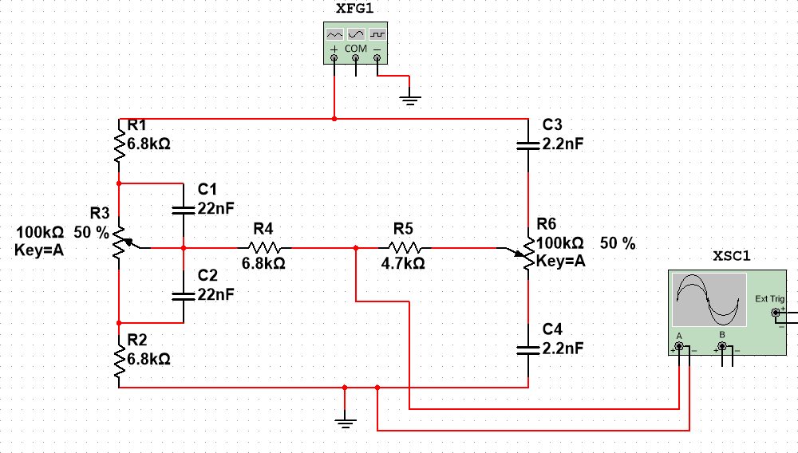

## Active Tone Control

* 1. High-Frequency Analysis：

As the frequency increases, the impedance of capacitors C1 and C4 decreases, approaching a short circuit, allowing high-frequency signals to pass more easily. At this point, the gain of the amplifier is primarily influenced by the variable resistors R1 and R6.

# When the variable resistor is turned left, the resistance value decreases, increasing the gain and thereby amplifying the high-frequency signals, making the high-frequency components more prominent.

* + **When the variable resistor is turned to the right, the resistance value increases, reducing the gain, which causes the high-frequency signals to be attenuated, weakening the high-frequency components in the output.**
  1. Low-Frequency Analysis：

As the frequency decreases, the impedance of capacitors C1 and C4 increases, approaching an open circuit, causing the low-frequency signals to be primarily influenced by the resistor network, especially the variable resistors R1 and R6.

# When the variable resistor is turned to the left, the resistance value decreases, increasing the gain, which enhances the low-frequency signals and makes the low-frequency components of the output signal more prominent.

* **When the variable resistor is turned to the right, the resistance value increases, reducing the gain, which causes the low-frequency signals to be attenuated, weakening the low-frequency components in the output.**

# Circuit

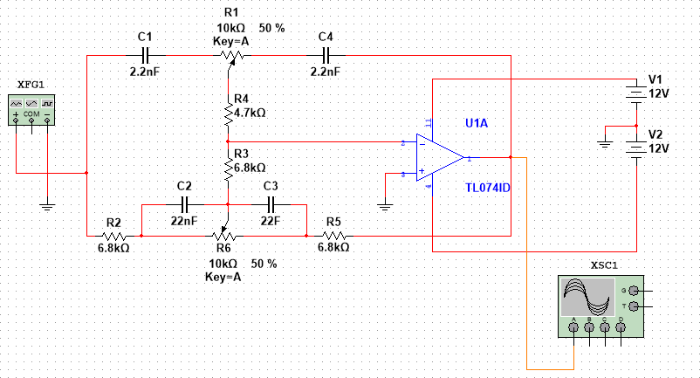

# Actual Circuit

# 

# Data

|  |  |  |  |  |  |  |  |  |  |  |  |  |  |
| --- | --- | --- | --- | --- | --- | --- | --- | --- | --- | --- | --- | --- | --- |
| The variable resistor set to the middle position. | | | | | | | | | | | | | |
| Freq. | 20 | 100 | 200 | 400 | 800 | 1k | 2k | 4k | 6k | 8k | 10k | 15k | 20k |
| Vo(p-p) | 2.16 | 2.18 | 2.12 | 2.08 | 2.12 | 2.18 | 2.16 | 2.18 | 2.18 | 2.16 | 2.18 | 2.18 | 2.18 |
| The variable resistor set to the maximum for both treble and bass. | | | | | | | | | | | | | |
| Freq. | 20 | 100 | 200 | 400 | 800 | 1k | 2k | 4k | 6k | 8k | 10k | 15k | 20k |
| Vo(p-p) | 28.6 | 15.6 | 9.8 | 4.2 | 2.96 | 2.6 | 2.2 | 2.76 | 3.56 | 4.36 | 5.08 | 6.6 | 7.6 |
| The variable resistor set to the minimum for both treble and bass. | | | | | | | | | | | | | |
| Freq. | 20 | 100 | 200 | 400 | 800 | 1k | 2k | 4k | 6k | 8k | 10k | 15k | 20k |
| Vo(p-p) | 80m | 280m | 480m | 880m | 1.46 | 1.64 | 1.66 | 1.56 | 1.22 | 1.02 | 880m | 660m | 580m |

# Data Processing or Plotting Process

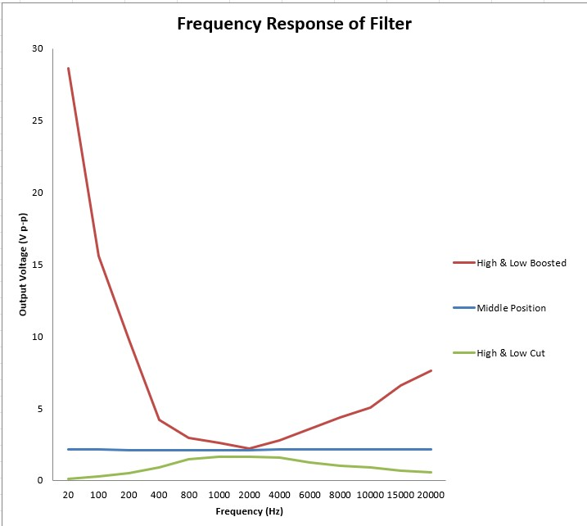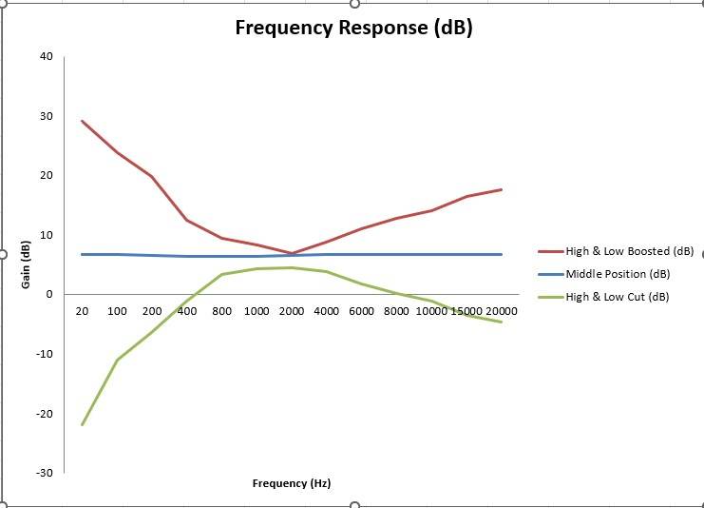

# Reflections

In this experiment, we tested the output voltage variations at different frequencies to observe the frequency response characteristics of the circuit. At the middle position, the output changes were small, indicating that the circuit's effect on different frequencies was relatively uniform. When the bass and treble were enhanced, we saw a significant increase in both low and high frequencies, while the midrange frequencies were comparatively weaker, which aligned with the expected equalization effect. Conversely, when the bass and treble were weakened, the output of both low and high frequencies dropped significantly, showing the circuit's attenuation effect on these frequencies. This experiment gave me a more intuitive understanding of the relationship between frequency response and circuit adjustment. I also learned how to use data analysis to present the circuit's characteristics. By plotting graphs in Excel, I was able to clearly observe the changes in the frequency response curve. This experiment also deepened my understanding of the principles behind audio circuits.